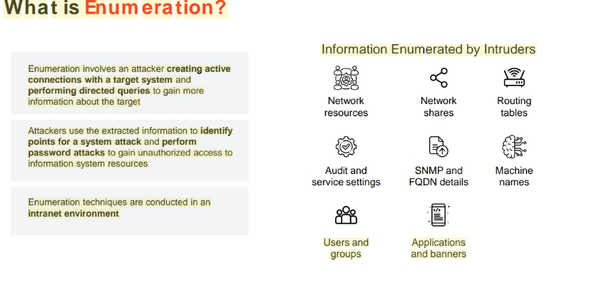
Service | Port(s) | Protocol(s) | Description
DNS Zone Transfer | 53 | TCP/UDP | Transfers DNS zone data between DNS servers.
Microsoft RPC Endpoint Mapper | 135 | TCP/UDP | Maps RPC services for Microsoft environments.
NetBIOS Name Service (NBNS) | 137 | UDP | Handles NetBIOS name registration and resolution.
NetBIOS Session Service (SMB over NBNS) | 139 | TCP | Establishes sessions using NetBIOS over TCP/IP.
SMB over TCP (Direct Host) | 445 | TCP/UDP | Direct SMB communication, typically for file sharing and Windows services.
SNMP (Simple Network Management Protocol) | 161 | UDP | Manages and monitors network devices.
SNMP Trap | 162 | TCP/UDP | Sends alerts/notifications from SNMP agents to managers.
LDAP (Lightweight Directory Access Protocol) | 389 | TCP/UDP | Accesses and maintains distributed directory information services.
Global Catalog (Microsoft LDAP) | 3268 | TCP | Allows searches across multiple domains in AD forests via the Global Catalog.
NFS (Network File System) | 2049 | TCP | Shares files across UNIX/Linux systems over a network.
SMTP (Simple Mail Transfer Protocol) | 25 | TCP | Sends email messages between mail servers.
ISAKMP/IKE (Internet Key Exchange) | 500 | UDP | Negotiates and manages IPsec security associations.
SSH (Secure Shell) | 22 | TCP | Provides secure command-line access to remote systems.
SIP (Session Initiation Protocol) | 5060, 5061 | TCP/UDP | 5060: Non-encrypted signaling; 5061: Encrypted with TLS for VoIP communications.
FTP (File Transfer Protocol) | 20, 21 | TCP | Transfers files; 21 for control, 20 or dynamic for data.
Telnet | 23 | TCP | Unencrypted remote access to networked devices.
TFTP (Trivial File Transfer Protocol) | 69 | UDP | Simple, unsecured file transfer protocol used for firmware/software updates.
BGP (Border Gateway Protocol) | 179 | TCP | Used by ISPs to manage routing tables and Internet traffic.

NetBIOS Enumeration (Port 137)
• NetBIOS provides name servicing, connectionless communication and some Session layer
stuff
• The browser service in Windows designed to host information about all machines within
domain or TCP/IP network segment
• NetBIOS name is a 16-character ASCII string used to identify devices
• Command on Windows is nbtstat o nbtstat (gives your own info) o nbtstat -n (gives
local table) o nbtstat -A IPADDRESS (gives remote information) o nbtstat -c (gives
cache information)
NetBIOS name resolution doesn't work on IPv6
• Other Tools o SuperScan o Hyena
o NetBIOS Enumerator: NetBIOS Enumerator is an enumeration tool that shows how to use remote network support and to deal with some other web protocols, such as SMB.
o NSAuditor

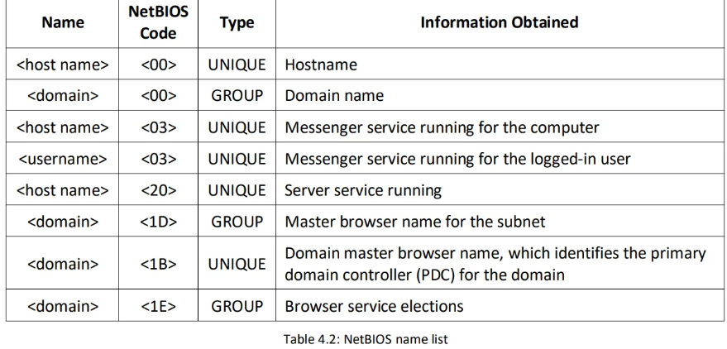
Tool/Command | Description | Common Usage
PsGetSid | Displays the Security Identifier (SID) of a computer or user. Useful for identifying domain users. | PsGetSid DOMAIN\User or PsGetSid \\ComputerName
PsExec | Executes commands on remote systems. Often used to run net user, whoami, or custom scripts. | PsExec \\Target cmd → net user, net localgroup administrators
PsFile | Lists or closes files remotely opened on a system (via SMB). | PsFile \\Target
PsKill | Terminates processes by name or PID on a local or remote system. | PsKill \\Target notepad.exe
PsInfo | Displays system information, including installed OS, uptime, and users (indirectly). | PsInfo \\Target
PsList | Provides detailed information about processes running on a system. | PsList \\Target
PsLoggedOn | Lists users logged on locally or via remote sessions. Useful for identifying active users. | PsLoggedOn \\Target
PsLogList | Dumps event logs from a system (Application, System, Security). | PsLogList \\Target -s
PsPasswd | Changes passwords for local or domain user accounts. | PsPasswd \\Target UserName NewPassword
PsShutdown | Shuts down, restarts, or logs off users from a remote computer. | PsShutdown \\Target -r -t 0 (restart immediately)
net view | Lists computers or shared resources in the network or a specific machine. | net view or net view \\ComputerName
📌 Notes
- net view is a built-in Windows command, not part of PsTools, but commonly used alongside it for enumeration.
- All PsTools commands require admin access and that the target is reachable with File & Printer Sharing enabled.
2. SNMP Enumeration (Port 161,162)
Use SNMP (application layer protocol) to obtain a list of user accounts and devices on system
• UDP Port 161 → Used by SNMP Managers to send requests to devices (like routers, switches, printers).
• UDP Port 162 → Used by SNMP Agents to send alerts or notifications (called Traps) back to the Manager.
• Management Information Base (MIB) - database that stores information. MIB elements are recognized using object identifiers (OIDs)
• Object Identifiers (OID) - identifiers for information stored in MIB
• SNMP GET - gets information about the system
• SNMP SET - sets information about the system
• Types of objects o Scalar - single object o Tabular - multiple related objects that can be grouped together
• SNMP uses community strings which function as passwords
• There is a read-only and a read-write version
• Default read-only string is public and default read-write is private
• These are sent in cleartext unless using SNMP v3
• Tools o Engineer's Toolset o SNMPScanner o OpUtils 5 o SNScan
SoftPerfect = “Soft-spy with Perfect vision”
Perform SNMP Enumeration using SnmpWalk
Using this tool, attackers target the root node so that information from all the sub-nodes such as routers and switches can be fetched.
nmap -sU -p 161 --script=snmp-processes <Target IP Address>
snmpwalk -v1 -c public 192.168.18.110 (-v1 is the version -c is the string)
For snmp version 2,use the following command snmpwalk -v2c -c public 192.168.18.110
SNMP Enumeration using snmp-check
first scan the target to check open port sudo nmap -sU -sV -p 161 192.168.18.110
Now enumerate it snmp-check 192.168.18.110
3. LDAP Enumeration (Port 389)
Lightweight directory access protocol (LDAP) is an Internet protocol for accessing distributed directory services
o Connects on 389 to a Directory System Agent (DSA) o Returns information such as valid user names, domain information, addresses, telephone numbers, system data, organization structure and other items
LDAP Enumertion with ldapsearch
Attackers use ldapsearch to enumerate AD users. This allows attackers to establish connections with an LDAP server to perform different searches using specific filters.
ldapsearch -h 192.168.18.110 -x -s base namingcontexts
(-x simple authentication -h specifies the host -s specifies the scope)
ldapsearch -h 192.168.18.110 -x -b "DC=CEH,DC=COM"
-b base DN for search
ldapsearch -h 192.168.18.110 -x -b "DC=CEH,DC=COM" "objectclass=*"
o Other Tools ♣ Softerra ♣ JXplorer ♣ Lex

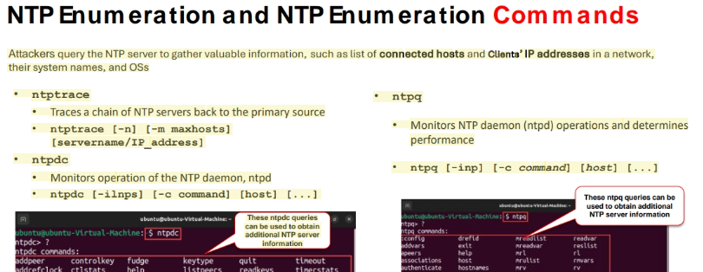
Runs on UDP 123
NTP Enumeration Tools
PRTG Network Monitor . Attackers use PRTG Network Monitor to retrieve SNTP server details such as the response time from the server, active sensors with the server, and synchronization time.

NFS Enumerationport 111 ans 2049(tcp)
NFS (Network File System) is a type of file system that enables computer users to access, view, store, and update files over a remote server. This remote data can be accessed by the client computer in the same way that it is accessed on the local system
rpcinfo -p <Target IP Address> (for an open NFS port (port 2049) )
RPCscan
RPCScan communicates with RPC (remote procedure call) services and checks misconfigurations on NFS shares. It lists RPC services, mountpoints,and directories accessible via NFS. It can also recursively list NFS shares.
./rpcscan.py 192.168.18.110 –rpc
SMTP Enumeration
SMTP enumeration is performed to obtain a list of valid users, delivery addresses, message recipients on an SMTP server. Ports 25,2525 or 587.
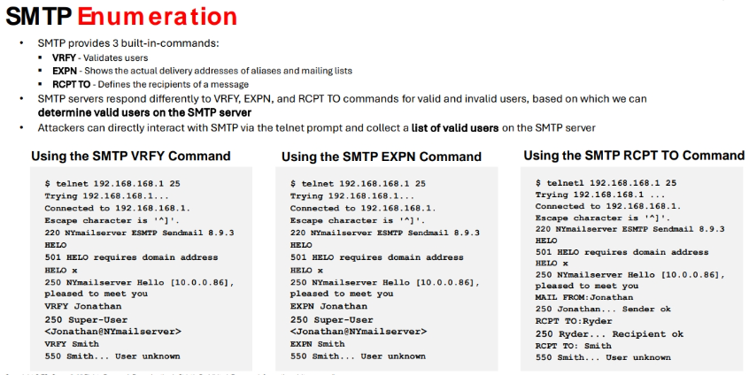 SMTP Enumeration using Nmap
enumerate smtp users nmap -p 25 --script=smtp-enum-users 192.168.18.110
Enumerate smtp relays on target nmap -p 25 --script smtp-open-relay 192.168.18.110
Enumerate smtp commands nmap -p 25 --script smtp-commands 192.168.18.110
Using this information, the attackers can perform password spraying attacks to gain unauthorized access to the user accounts.
SMTP Enumeration Tool
▪ NetScanTools Pro Attackers use NetScanTools Pro for SMTP enumeration and extract all the email header parameters, including confirm/urgent flags
▪ smtp-user-enum is performed by inspecting the responses to VRFY, EXPN, and RCPT TO commands
5. DNS Enumeration
DNS enumeration techniques are used to obtain information about the DNS servers and network infrastructure of the target organization.
Common DNS Enumeration Techniques:
1. Zone Transfers: Copying the zone file from a primary DNS server to a secondary DNS server (when improperly configured).
Example: host -l domain.com dns-server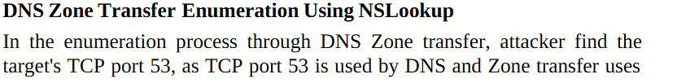
dig Command
Attackers use the dig command on Linux-based systems to query the DNS name servers and retrieve information about the target host addresses, name servers, mail exchanges, etc.
dig ns <target domain>
DNSRecon
Attackers use DNSRecon to check all NS records of the target domain for zone transfers. As shown in the screenshot, attackers use the following command for DNS zone transfer: dnsrecon -t axfr -d <target domain>
2. DNS Cache Snooping
• DNS cache snooping is a DNS enumeration technique whereby an attacker queries the DNS server for a specific cached DNS record
Non-recursive Method
Attackers send a non-recursive query by setting the Recursion Desired (RD) bit in the query header to zero
Recurs A high TTL value indicates that the record was not in the cache
DNS Queries: Retrieving specific record types (A, MX, NS, CNAME, SOA, TXT, etc.).
Example: nslookup -type=MX domain.com
3. DNSSEC Zone Walking
▪ DNSSEC zone walking is a DNS enumeration technique where an attacker attempts to obtain internal records of the DNS server if the DNS zone is not properly configured
▪ Attackers use tools, such as LDNS and DNSRecon, to exploit this vulnerability and obtain the network information of a target domain and further launch Internet-based attacks
This security feature uses digital signatures based on public-key cryptography to strengthen authentication in DNS. These digital signatures are stored in the DNS name servers along with common records such as MX, A, AAAA, and CNAME
ldns-walk @<IP of DNS Server> <Target domain>
4. DNS Enumeration Using OWASP Amass
OWASP Amass is a DNS enumeration tool that allows attackers to map the target network and discover potential attack surfaces
OWASP Amass commands for DNS Enumeration
• Command to perform a passive enumeration: amass enum -passive -d <Target Domain> -src
• Command to perform an active enumeration through brute-forcing : amass enum -active -d <Target Domain> -brute -w /usr/share/wordlists/amass/all.txt
• Command to track or compare the last two enumeration scans : amass track -config /root/amass/config.ini -dir amass4owasp -d <Target Domain> -last 2.
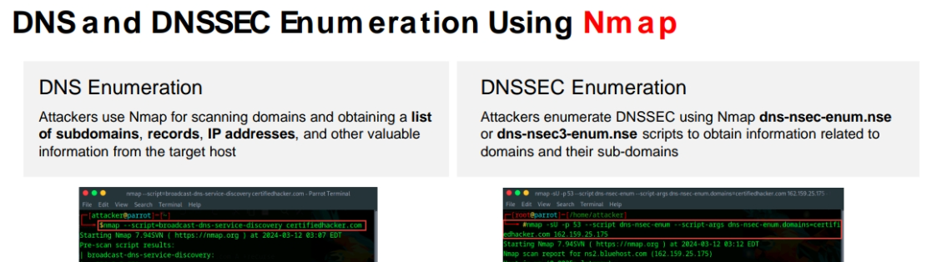

🧭 Other Enumeration Techniques

🔐 1. IPsec Enumeration (ISAKMP/IKE – UDP 500)
Purpose: Discover VPN gateways, supported encryption/auth algorithms, and pre-shared key (PSK) weaknesses.
- Tools:
  - ike-scan( ike-scan –M <target gateway IP addr) ike-scan discovers IKE hosts and can fingerprint them using the retransmission backoff pattern.
  - nmap (--script ike-version)
- Example:
ike-scan -M -A <target>
nmap -sU -p 500 --script ike-version <target>
- Goal: Identify IKE Phase 1 configuration and attempt weak PSK brute-force.

📞 2. VoIP Enumeration (SIP – TCP/UDP 5060, 5061,2000,2001)
Purpose: Enumerate SIP endpoints, extensions, and possible usernames.
VoIP enumeration provides sensitive information, such as VoIP gateway/servers, IP-PBX systems, client software (softphones)/VoIP phones, User-agent IP addresses, and user extensions
This information can be used to launch various VoIP attacks, such as Denial-of-Service (DoS), Session Hijacking, Caller ID spoofing, Eavesdropping, Spamming over Internet Telephony (SPIT), and VoIP phishing (Vishing)
- Tools:
  - sipvicious (svmap, svwar, svcrack) # svmap <target network range/IP Address>
  - nmap with SIP NSE scripts
- Example:
svmap <target>
svwar -m INVITE -i <target> # Extension enumeration
- Goal: Identify active VoIP users, services, and try default or weak credentials.

⚙️ 3. RPC Enumeration (TCP/UDP 135)
Purpose: List RPC services, enumerate users, shares, and domain info.
Remote Procedure Call (RPC) allows clients and servers to communicate in distributed client/server programs
• Enumerating RPC endpoints enables attackers to identify any vulnerable services on these service ports
- Tools:
  - rpcclient
  - nmap --script
- Example:
- # nmap -sR <target IP/network> # nmap -T4 –A <target IP/network>
- Goal: Extract domain information, users, and possibly perform SID brute-forcing.

🐧 4. Unix/Linux User Enumeration
Purpose: Identify local users, groups, sudoers, and more.
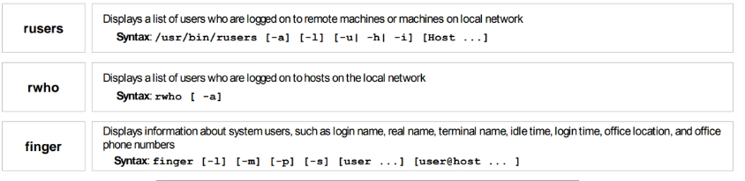

- Techniques:
  - Check /etc/passwd, /etc/shadow, /etc/group (requires local access or misconfigured permissions).
  - SSH banner grabbing for usernames.
  - Bruteforce with hydra, medusa, or ncrack.
- Goal: Identify valid login accounts and escalate privileges via misconfigurations.

📁 7. SMB Enumeration (TCP 445/139)
Purpose: List users, shares, groups, policies.
Attackers use SMB enumeration tools, such as Nmap, SMBMap, enum4linux, and nullinux, to perform a directed scan on the SMB service running on port 445
▪ SMB enumeration helps attackers to perform OS banner grabbing on the target
- Example:
# nmap -p 445 -A <target IP>
- Goal: Extract usernames, group membership, share names, and Windows domain info.

✅ Summary Table
Service | Ports | Key Tool(s) | Goal
IPsec | UDP 500 | ike-scan, nmap | Discover VPN config and weak PSKs
VoIP (SIP) | 5060, 5061 | sipvicious, nmap | Discover SIP users/extensions
RPC | 135 | rpcclient, nmap | Enumerate domain users and policies
Unix/Linux | N/A | /etc/passwd, getent | List local accounts, groups
Telnet | TCP 23 | hydra, nmap | Login prompt enumeration, brute-force
SSH | TCP 22 | hydra, nmap | Username validation, brute-force
SMB | 139/445 | enum4linux, smbclient | Enumerate users, shares, groups
